ROSSMOYNE SENIOR HIGH SCHOOL

Semester Two 2011

Trial WACE Examination, 2011

Question/Answer Booklet

MATHEMATICS 3A/3B

Section Two:

Calculator-assumed

NAME:
TEACHER: Benko Fletcher Goh Longley Pui

(Circle one name) Rigelsford Robinson Tanday Tay White Whyte

Time allowed for this section
Reading time before commencing work: ten minutes
Working time for this section: one hundred minutes

Materials required/recommended for this section

To be provided by the supervisor
This Question/Answer Booklet
Formula Sheet (retained from Section One)

To be provided by the candidate
Standard items: pens, pencils, pencil sharpener, eraser, correction fluid/tape, ruler, highlighters

Special items: drawing instruments, templates, notes on two unfolded sheets of A4 paper, and up to three calculators satisfying the conditions set by the Curriculum Council for this examination.

Important note to candidates

No other items may be used in this section of the examination. It is your responsibility to ensure that you do not have any unauthorised notes or other items of a non-personal nature in the examination room. If you have any unauthorised material with you, hand it to the supervisor before reading any further.

Structure of this paper

Section | Number of questions available | Number of questions to be answered | Working time (minutes) | Marks available | Percentage of exam
Section One:  Calculator-free | 7 | 7 | 50 | 40 | 33
Section Two:  Calculator-assumed | 13 | 13 | 100 | 80 | 67
 |  |  | Total | 120 | 100

Instructions to candidates

- The rules for the conduct of Western Australian external examinations are detailed in the Year 12 Information Handbook 2011. Sitting this examination implies that you agree to abide by these rules.

- Write your answers in the spaces provided in this Question/Answer Booklet. Spare pages are included at the end of this booklet. They can be used for planning your responses and/or as additional space if required to continue an answer.
- Planning: If you use the spare pages for planning, indicate this clearly at the top of the page.
- Continuing an answer: If you need to use the space to continue an answer, indicate in the original answer space where the answer is continued, i.e. give the page number. Fill in the number of the question(s) that you are continuing to answer at the top of the page.

- Show all your working clearly. Your working should be in sufficient detail to allow your answers to be checked readily and for marks to be awarded for reasoning. Incorrect answers given without supporting reasoning cannot be allocated any marks. For any question or part question worth more than two marks, valid working or justification is required to receive full marks. If you repeat an answer to any question, ensure that you cancel the answer you do not wish to have marked.

- It is recommended that you do not use pencil, except in diagrams.

Section Two: Calculator-assumed (80 Marks)
This section has thirteen (13) questions. Answer all questions. Write your answers in the spaces provided.

Working time for this section is 100 minutes.

Question 8 (3 marks)
The scores of 25 students in a test out of 70 are listed below in ascending order.

25 | 26 | 28 | 28 | 29
34 | 36 | 39 | 44 | 45
47 | 48 | 51 | 54 | 55
55 | 57 | 58 | 60 | 60
60 | 61 | 64 | 68 | 69

(a) How many students scored the same as the mode? (1 mark)

(b) Calculate the interquartile range for these scores. (2 marks)

Question 9 (9 marks)
The length of time between calls of the grey tree frog is known to vary with the ambient temperature. Data for temperatures from 11°C to 33°C are shown in the table below.

Temperature  (°C) |  | 11 | 12 | 14 | 15 | 17 | 18 | 20 | 21 | 23 | 24 | 26 | 30 | 32 | 33
Time between  calls (seconds) |  | 4.3 | 5.1 | 5.9 | 6 | 7.1 | 6.9 | 5.8 | 6.1 | 5.2 | 5.2 | 4.4 | 3.5 | 2.5 | 2.4

(a) Use your calculator to graph the data and comment on any trends you notice. (2 marks)

(b) By careful selection of data from the above table, calculate a linear regression model of the form 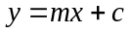suitable for temperatures above 16°C. (2 marks)

(c) How confident are you that a linear model is appropriate in part (b)? Justify your answer with reference to Pearson's correlation coefficient. (2 marks)

(d) Calculate the residual time for a temperature of 20°C using the regression model from part (b). (2 marks)

(e) Comment on the statement "Due to the strong association evident between temperature and time, we can be certain that high temperatures cause grey tree frogs to have shorter time intervals between calls." (1 mark)

Question 10 (4 marks)

The two variables and are inversely proportional to one another.

(a) Circle each of the equations below that reflect this relationship, where is a constant.
(2 marks)

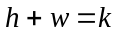 | 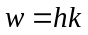 | 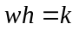 | 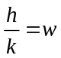 | 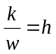 | 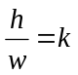

(b) When 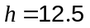, 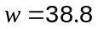. If decreases by 2.8, by how much will change? (2 marks)

Question 11 (9 marks)
The histogram below shows the distribution of ages of the under-90 male population of Australia in the year 2010. The mean and standard deviation of the data shown are 36.6 and 21.7 years respectively.

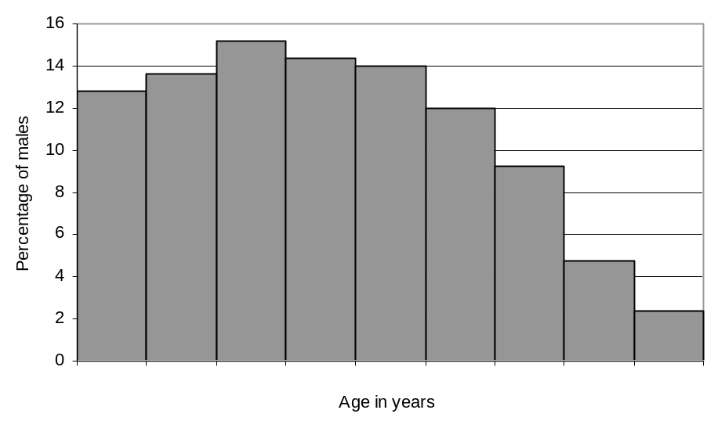

(a) Describe the spread of the data shown in the histogram. (2 marks)

(b) If the data had been presented as a boxplot, would you expect the length of the left hand whisker to be greater than, about the same as, or less than, the length of the right hand whisker? Explain your answer. (2 marks)

The table below shows the distribution of ages of the under-90 female population of Australia in the year 2010.

Age in years () | Percentage of females
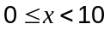 | 12.3
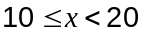 | 12.7
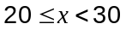 | 14.6
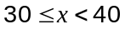 | 14.8
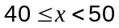 | 14.2
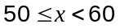 | 12.6
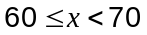 | 9.4
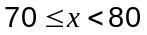 | 5.7
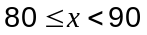 | 3.7

(c) Calculate the mean and standard deviation of the female ages. (2 marks)

(d) Comment on any similarities or differences between the male and female age distributions. (3 marks)

Question 12 (8 marks)
The graph below shows the lines 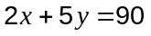 and 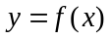.
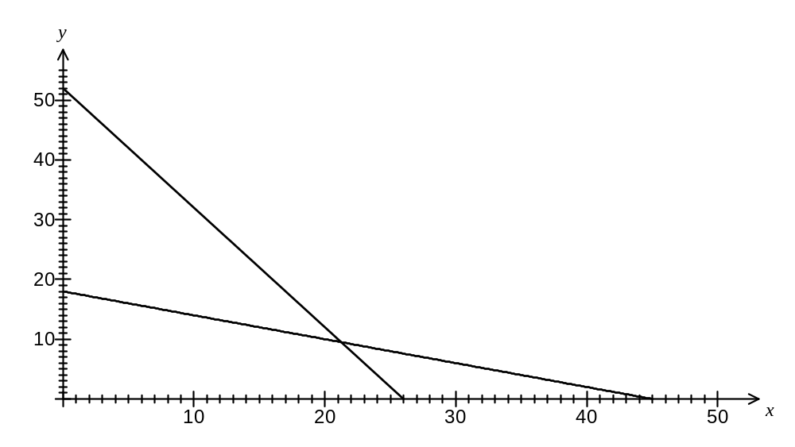
(a) Determine the equation of . (1 mark)

(b) Add the line 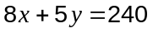 to the graph above. (1 mark)

(c) Shade the feasible region defined by 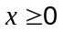, 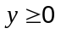, 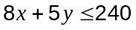, 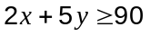and 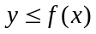. (2 marks)

(d) Find the values of and that maximise the objective function 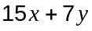 subject to the constraints in part (c) and state this maximum value. Justify your answer. (4 marks)

Question 13 (6 marks)
A quality control officer at a soft-drink bottling plant uses systematic sampling to select close to 0.2% of bottles filled for checking.

(a) Describe a practical way that the systematic sampling might be carried out. (2 marks)

On a particular day, the content of a bottle of soft-drink was observed to be normally distributed with a mean of 382.3 mL and a standard deviation of 2.9 mL.

(b) How many bottles in a sample of 500 would be expected to contain less than the stated content of 375mL? (2 marks)

(c) Calculate the 95th percentile for this distribution. (2 marks)

Question 14 (4 marks)
Consider the function 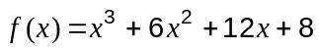.

(a) Use your calculator to factorise . (1 mark)

(b) Describe how the graph of can be obtained from the graph of 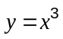. (1 mark)

(c) The graph of the function 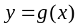 is shown below and is congruent with the graph of . Determine 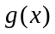 in the expanded form 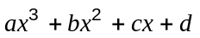. (2 marks)
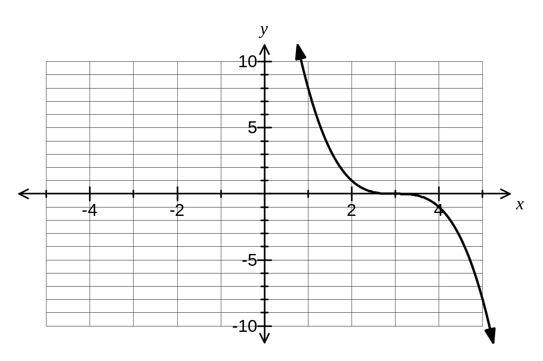

Question 15 (4 marks)
A thin piece of glass has been cut into the shape of an obtuse-angled triangle with an area of 135.5 cm² and two sides of 21.8 cm and 25.4 cm. Calculate the length of the third side, correct to 3 significant figures.

Question 16 (7 marks)
Three functions are given by 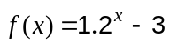, 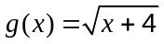 and 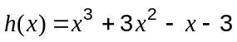.
Their graphs are shown on the axes below.
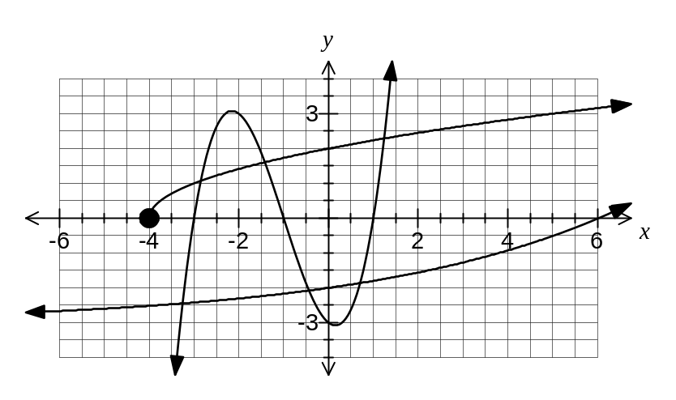

(a) What is the domain of ? (1 mark)

(b) For which function is the domain the same as the range? (1 mark)

(c) State which function has an asymptote and write down the equation of this asymptote.
(2 marks)

(d) Use the graph to estimate all solutions to 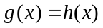. (2 marks)

(e) From the above graph it could be deduced that there are 3 solutions to the equation 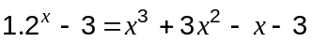. Briefly explain whether or not you agree that there are 3 solutions to the equation. (1 mark)

Question 17 (5 marks)
The daily sales figures for a new clothing store are shown in the table below. The figures in column a are the six-point centred moving averages of the sales data, rounded to the nearest dollar. The regression line of a on t from this data is 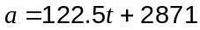, with a correlation coefficient of 0.97.

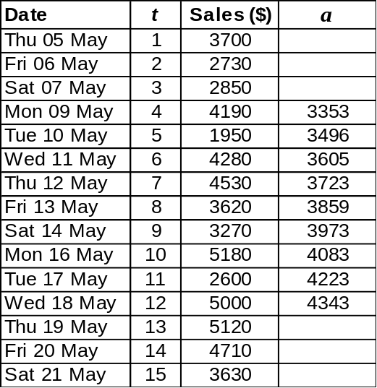

(a) Write down the calculation used to find the six-point centred moving average for Mon 16 May. (1 mark)

(b) Predict, with seasonal adjustment, the likely sales for Mon 23 May, assuming that existing trends continue. (4 marks)

Question 18 (7 marks)
The spreadsheet below was used to model the balance of an annuity used to help pay the university fees of a student. $19 000 was deposited in a fixed-interest savings account at the start of the year 2011. One year later interest was added and then the student withdrew $4 480. This process was repeated until the balance of the annuity reached zero at the start of the year 2016.
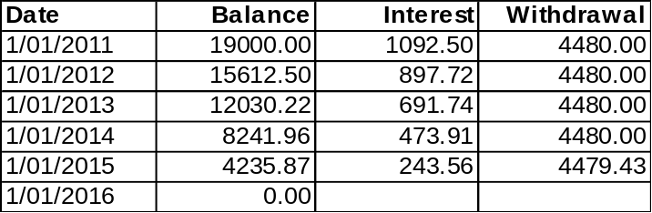

(a) How much did the annuity provide in total towards the student's university fees? (1 mark)

(b) What was the annual percentage interest rate? (1 mark)

(c) Explain why the final withdrawal was less than $4 480. (1 mark)

(d) Write a recursive rule to generate the balance at the start of each year from 2011 until 2015. (2 marks)

(e) Suggest two changes to this annuity so that it would provide a larger amount towards the student's university fees. (2 marks)

Question 19 (6 marks)
A cylinder of radius r and height h is such that the sum of the radius and height is 42cm.

(a) Show that the volume of the cylinder is given by 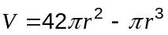. (2 marks)

(b) Use calculus techniques to find the maximum possible volume of the cylinder. (4 marks)

Question 20 (8 marks)
A small toy train is able to travel backwards and forwards along a straight track built on level ground. The displacement in metres, of the train relative to point A, is shown on the graph below for the interval 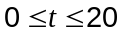seconds.
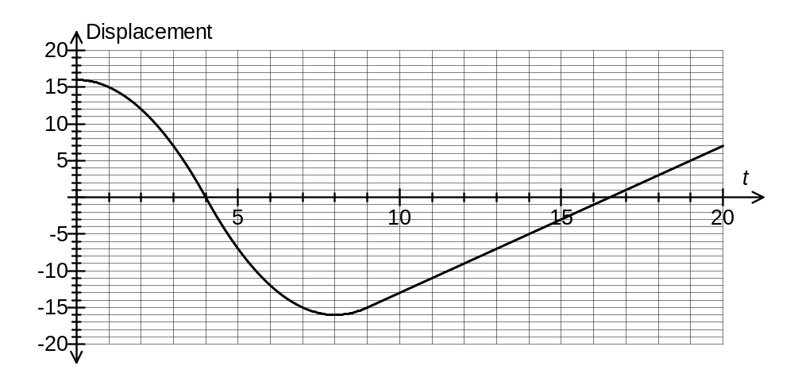
(a) State an interval of time during which the train is moving towards point A. (1 mark)

(b) What total distance did the train travel during the 20 second interval? (1 mark)

(c) In what interval of time was the rate of change of displacement constant and what was that rate of change, in centimetres per minute? (3 marks)

(d) Estimate the area between the time axis and the displacement graph for the interval 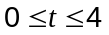seconds using the average area of circumscribed and inscribed rectangles with widths of 1 second. (3 marks)

Additional working space

Question number: _________

Additional working space

Question number: _________

Additional working space

Question number: _________

